Q. Why we need generics in java ?

Ans. To reuse code with different output.

Q. why generics is prefer over Object class?

Ans

Case 1:

List ls=new ArrayList();

ls.add(“Deepak”);

String name=(String)ls.get(0);

Case 2:

List<String> ls=new ArrayList<>();

Ls.add(“Deepak”);

String name=ls.get(0);

Note : in case 1 we need to type case value from string to object at runtime;

In case 2 we don’t need to type cast or we can say that type casting is done at compile time.

Q. How to create generic class ?

Ans:

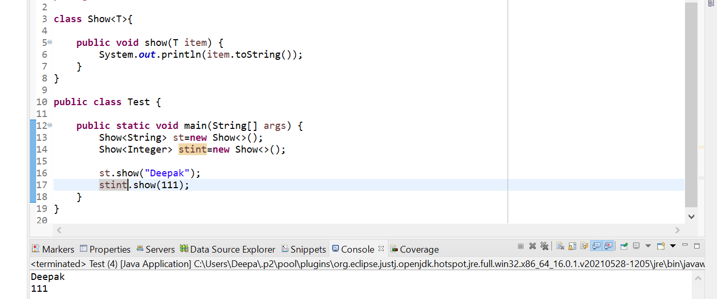

Q. Can we create generic methods without class ? and handling of multiple value

Ans : Yes, we can

